Different length of sports tracks the sports stadium.
Practical demonstration of Mathematics.
It is certain that each track on sports stadium is different length .
If athletes want to run only one round and they are in different tracks , they can not start on one line.

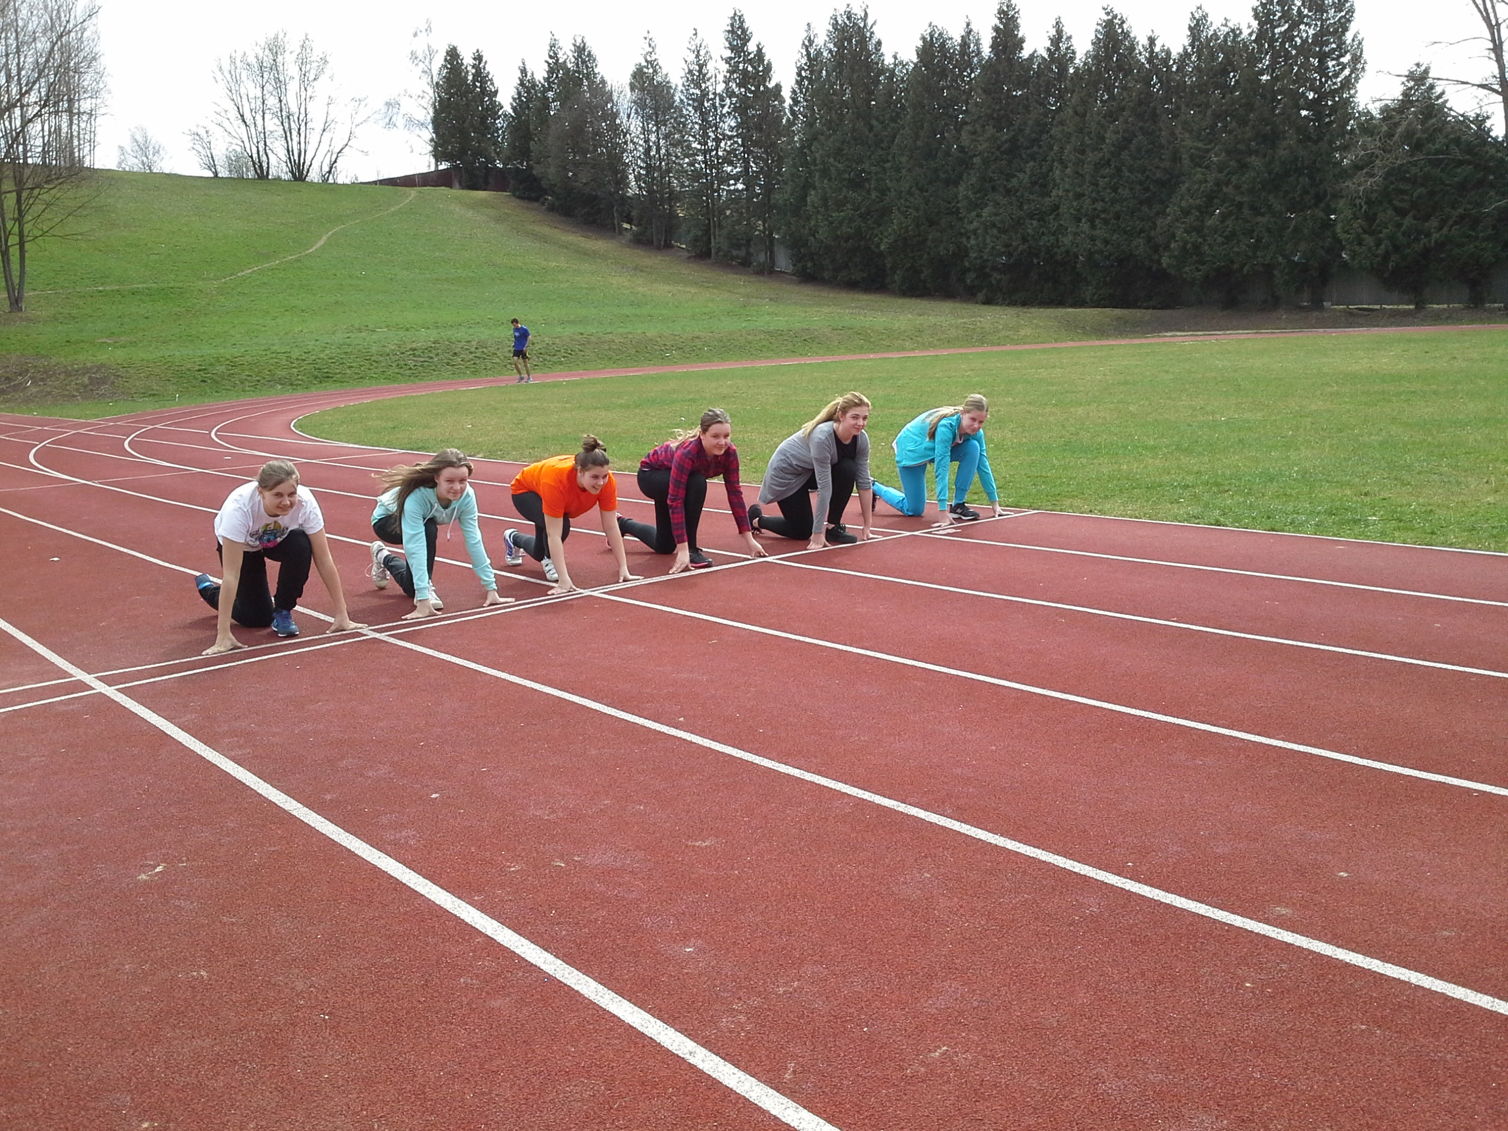

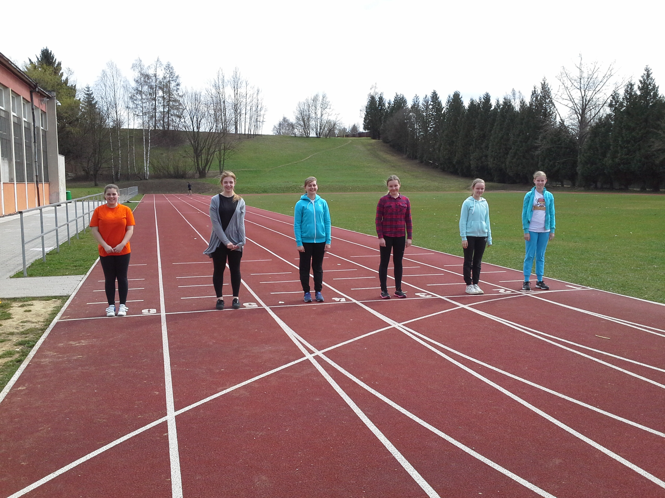

Let's calculate the difference length of tracks.
We must know the width of a single track.
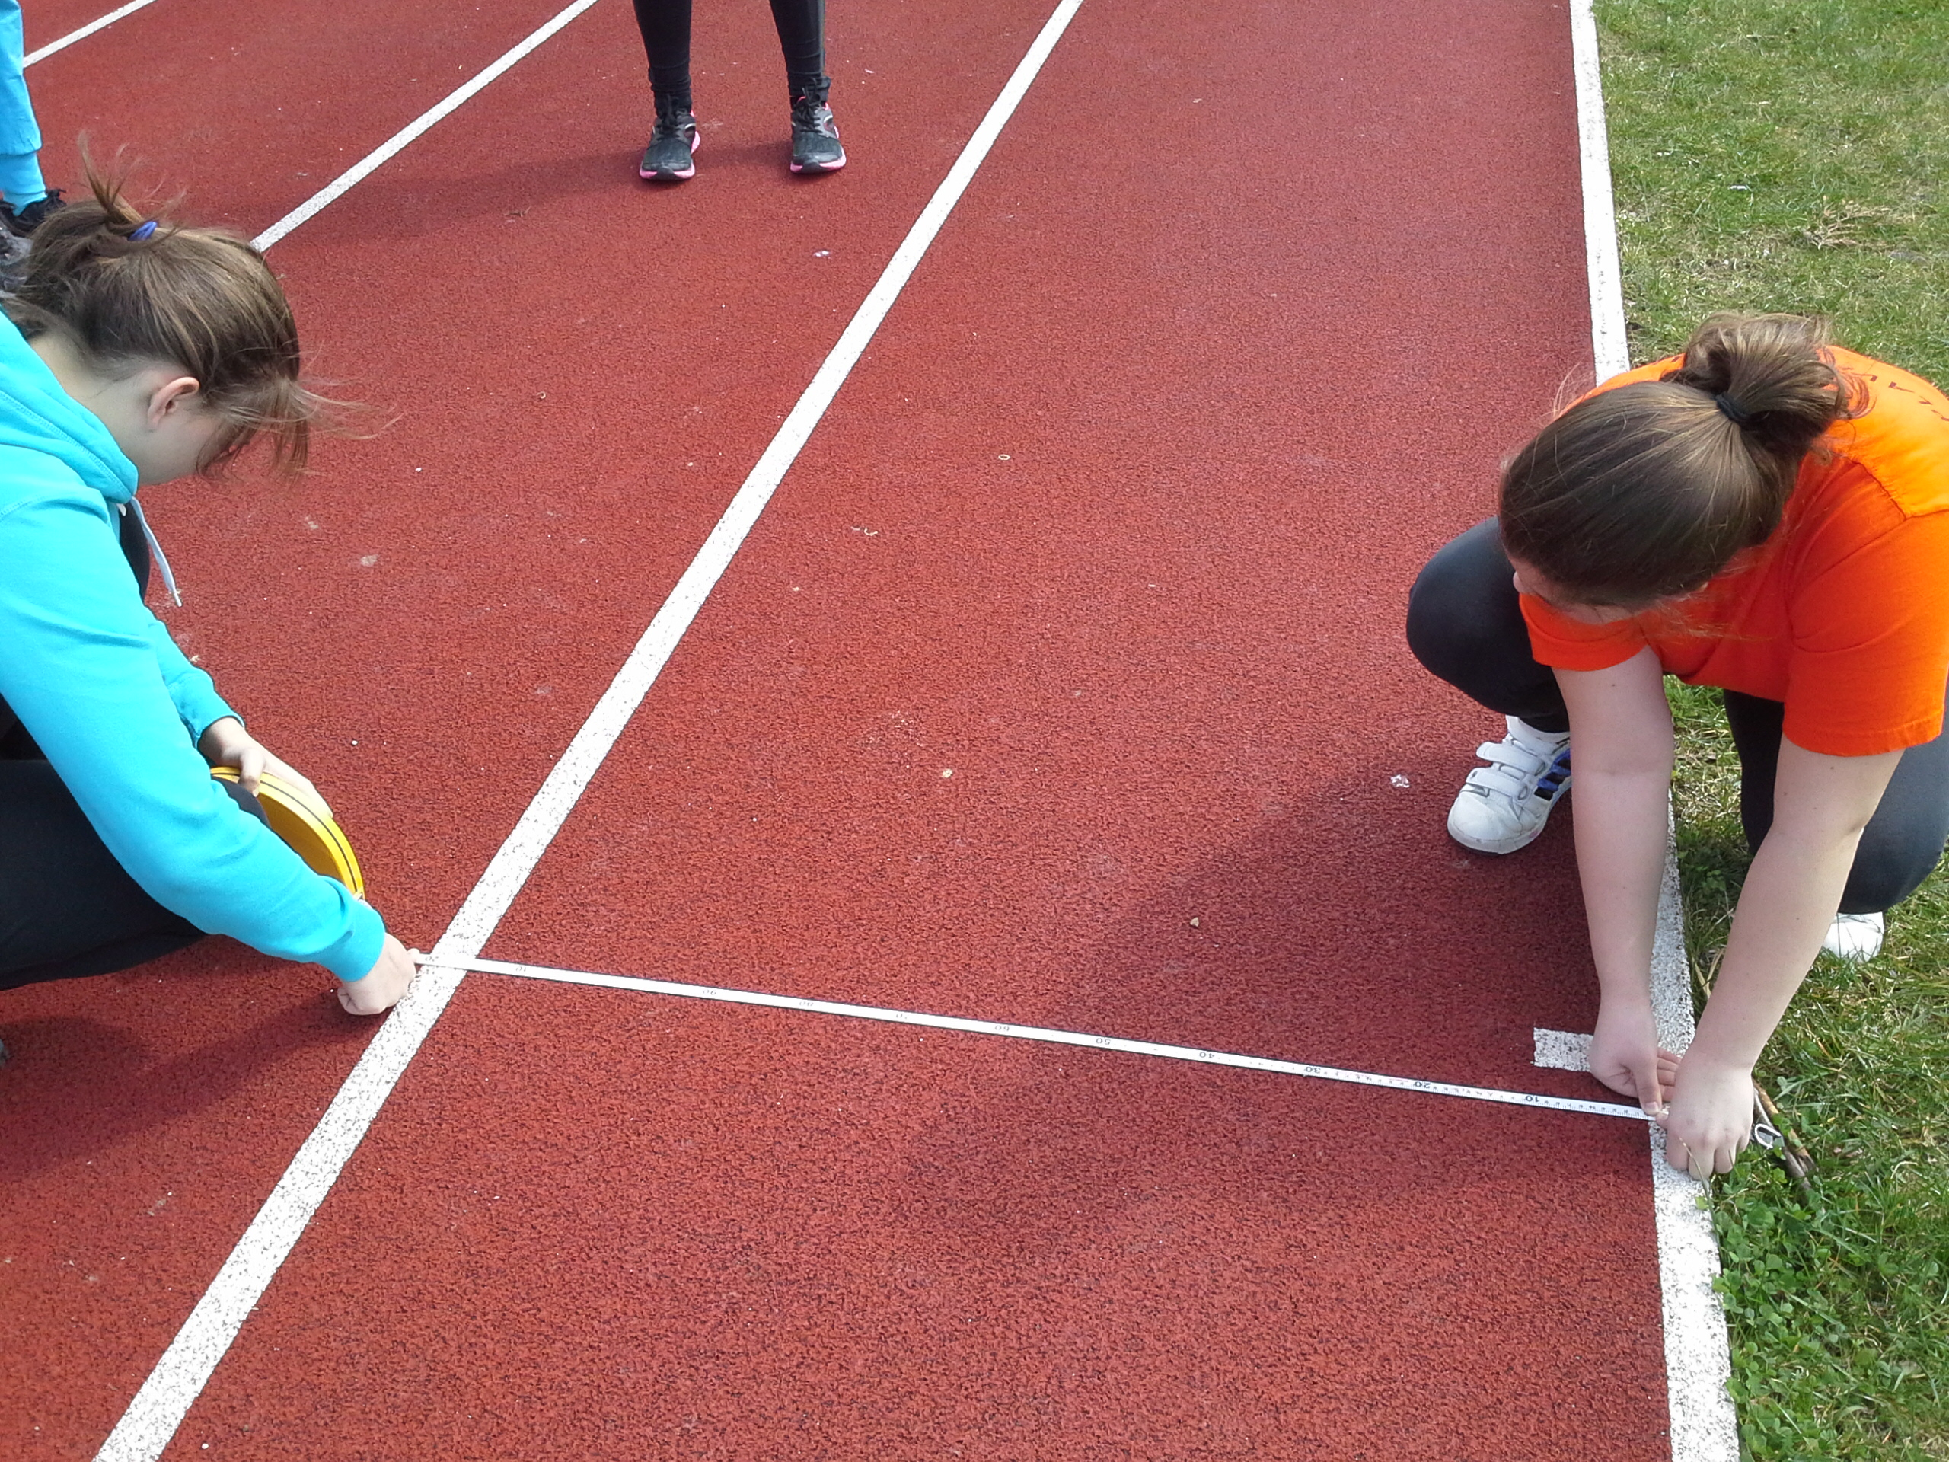

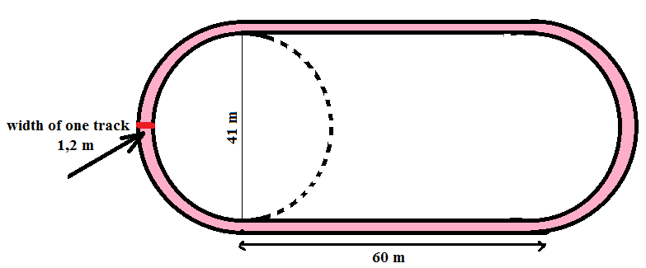

So counting:

Circumference is π x d = 3,14 x 41 = 128,74 m d is diameter circle
Perimeter first running track is ......128,74 + 60 + 60 = 248,74 m approximated 249 m.

Width of one track is 1,2 m, after that perimeter second (next) track is :

π x ( d + 2,4) = π x d + π x 2,4 = 128,74 m+ 7,54 m = 136,28 m
Perimeter: 60 + 60 + 136,28 m = 256,28 m.

So the difference length of tracks is 7,54 m.
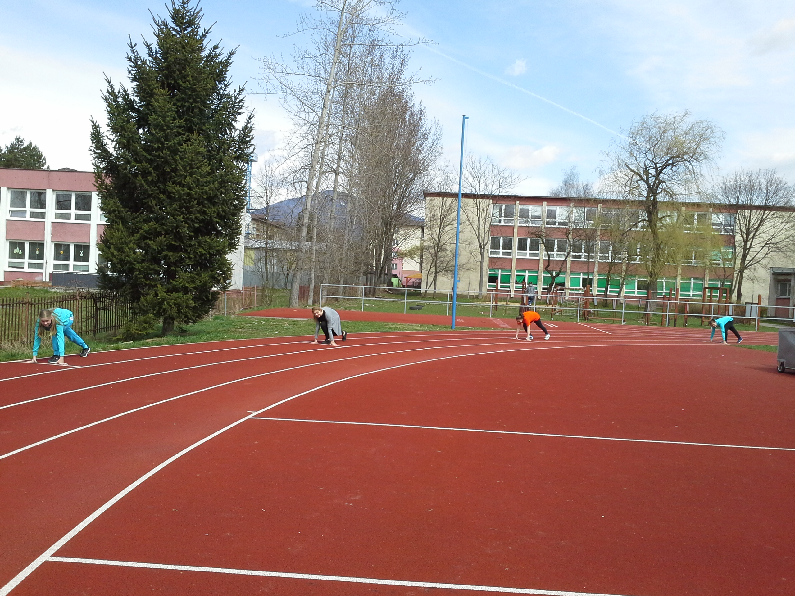
Mária Debnárová BellAmos Martin Slovakia

